**STANDARD OPERATING PROCEDURES**

**Williamson Shooting Sports Complex (WSSC)**

**& Camp Garland Cub Scout Ranges**

**Mabee Scout Reservation**

**Indian Nations Council, B.S.A.**

**Revised: February 2025**

**RANGE OPERATIONS GUIDE**

**1. Introduction**

Shooting sports activities conducted at the ranges of the Indian Nations Council, BSA are designed to provide authorized users with access to a facility where they have the opportunity to become proficient in the Shooting Sports and participate in council sponsored events.

These guidelines are to be used in conjunction with relevant and most current BSA publications:

National Range and Target Activities Manual 2024 #430-938

NCAP National Camp Standards #430-056

Guide to Safe Scouting #34416

It is understood that National BSA committees and task forces may periodically revise Shooting Sports standards and requirements. Every effort will be made to reflect those changes in the WSSC SOP’s.

**2. Authorized Users**

* 1. Current youth and adult members of the Boy Scouts of America as authorized in the Guide to Safe Scouting & Age Appropriate Guidelines for BSA Activities.
  2. Immediate family members or invited guests of the above, provided the authorized user is present and assumes full responsibility for the conduct of his or her guest(s)
  3. Maximum of two guests please (not including family members).
  4. Non-Scout Individuals approved by the Indian Nations Council on a case-by-case basis, and who have executed a Hold Harmless Agreement. Non-Scout trainers and groups must have Indian Nations Council approval.
  5. Participants in council sponsored activities.
  6. Have your approved Range Reservation documents (with receipt and certification cards) with you when you arrive at camp.
  7. No Cub Scout shooting activities on the WSSC ranges.  
     Cub Scout BB, Archery, & Wrist Rockets on Camp Garland Cub Scout Ranges ONLY. Cub Scout Shooting Sports are limited to Council and District events ONLY.

**3. Reservation Procedures & Facility and Equipment Availability**

* 1. Reservations for use of the Williamson Shooting Sports Complex ranges should be made a minimum of 3 weeks in advance through the Indian Nations Council Volunteer Resource Center.
  2. No later than 3 business days prior to your activity, confirm your WSSC Reservation and complete the WSSC Range Fee form, noting the number of participants, and prepay your facility use and expected expendable charges.
     + Qualified supervision for each venue must be identified and copies of current   
       training certificates must be attached to the Range Fee form.
     + At least one qualified scouter who has completed the WSSC Facility Orientation must be listed on the Range Fee form and must be on-site during range activity.
  3. Upon arrival at WSSC users will provide copies of reservation form, training documentation, and fee form to the Camp Ranger or Lead RSO hosting the range event.
  4. Users may be requested to “share the range” with other groups. Each group will be expected to share appropriate supervision duties.
  5. **Personal Firearms or Archery Tackle are NOT Permitted (BSA guidance 9/01/24)   
      INC declared Exception: Use by Certified Instructor for Instructional sessions.**~~If your unit is bringing unit-owned shooting sports equipment to the WSSC ranges, you may NOT use any of the WSSC shooting sports equipment (rifles, shotguns, pistols, muzzleloading rifles, and/or bows, arrows, and archery targets, and accessories).~~
* ~~You may use the target stands and frames, plus shooting benches and seats at the Rifle Range.~~
* ~~Individuals may not bring personal firearms or ammunition to WSSC.~~
* ~~Individuals may not bring personal archery equipment to WSSC.~~
* ~~You MUST use the Range Flags, RSO vests, shotgun traps and clay targets provided at WSSC.~~
* ~~If a unit is using WSSC firearms, WSSC ammunition must be used exclusively~~
  1. For District or Council activities: ONLY WSSC firearms, ammunition, and targets may be used.
  2. Range supervision is expected to make accurate, factual entries in the Inventory and Range Log Books.
  3. Before you leave WSSC the Camp Ranger and Range supervision will complete a Range Log for each range used. Included will be a review of items used vs. balance on hand, firearms cleaned and oiled, range facilities clean and orderly.
  4. *Return Range* ***KEYS*** *back to the Camp Ranger.*
  5. You are expected to pay for the materials you use. Should you use more than your original estimate, please pay the difference within 5 business days at the Scout Resource Center. Should you not use the quantity for which you have prepaid, you may submit a credit request. The Camp Ranger will verify quantities of ammunition.
  6. Your entire group is expected to comply with all general rules and safety requirements.

**4. BSA Shooting Sports Supervision -- Required Certification or Training**

|  |  |  |  |  |  |  |
| --- | --- | --- | --- | --- | --- | --- |
| **Venue (Max # positions)** |  | **NRA Range Safety Officer** | **NRA  Instructor or Coach** | **Cub Scout BB Gun Rangemaster** | **USA Archery Level 1 Instructor** | **Cub Scout Archery Rangemaster** |
|  |  |  |  |  |  |  |
|  |  |  |  |  |  |  |
| Archery (12) |  |  |  |  | **1 per 8 shooters** |  |
| Rifle (14) |  | **1 per 8 shooters** | **1 per 8 shooters** |  |  |  |
| Shotgun (6) |  | **1 per 6 shooters** | **1 per 1 shooters** |  |  |  |
| **Pistol (12) Venturing Only** |  | **1 per 3 shooters** | **\* 1 per 1 shooters** |  |  |  |
| Muzzleloading Rifle (8) |  | **1 per 8 shooters** | **1 per 1 shooters** |  |  |  |
| Cub Scout BB Gun (10) |  |  |  | **1 per 8 shooters** |  |  |
| Cub Scout Archery (12) |  |  |  |  |  | **1 per 8 shooters** |
| Cub Scout Sling Shot (8) or Wrist Rocket |  |  |  | **1 per 8 shooters** |  |  |
| Webelos Air Rifle (8)  **Resident Camp Only** |  |  | **1 per 8 shooters** |  |  |  |

* One NRA Pistol Instructor per 2 shooters if all pistol shooters have completed either the NRA FIRST Steps (3 hours) Pistol Course or NRA Basics of Pistol Shooting Course (8 hours).

**Tigers and their adult partners may participate in BB gun shooting, Archery, and Slingshot activities.** The adult partners must be included in all shooting activities. Each Tiger must be paired with his adult partner on the range before being allowed to shoot.

***Kindergarten–age youth in the Lion program are NOT approved to participate in Cub Scout BB-gun activities.***

**Slingshot and Wrist Rocket** - A Cub Scout BB & Archery Rangemaster must be present plus a 1-to 1 adult-to-boy ratio must be used. Use a safe shooting range such as a BB gun range or archery range. Wear protective eyeglasses. (see pgs. 163-164, 2024 BSA National Range & Target Activities Manual for additional info.

**5. Alcoholic Beverages and Drugs**

Range Operations Personnel or Shooters may not consume alcoholic beverages or drugs (including prescription and over-the-counter medications) which may cause drowsiness or inhibit reactions, before or during live firing. The Lead RSO or RSO shall deny range access to anyone in violation.

**6. Emergency Procedures**

1. The supervising leader will take charge of the situation. (Determine seriousness of injury)
2. Render first aid if qualified. First Aid Kits located in Rifle and Archery Range buildings.
3. If EMS is required:

1. Call **Tyrel Bell**, Mabee Scout Reservation Ranger at **918-639-1596**   
 …. if unavailable  
 Call 911 for help via cell phone if necessary. Identify location as “Boy Scout Camp south of Locust Grove”  
2. CEASE FIRE on all ranges if EMS is required.  
3. Meet EMS at MSR Main Gate and direct help to location.

1. Take notes.
2. Record incident in First Aid Log.

**7. Range Personnel**

On days when multiple venues are in operation the Council Shooting Sports Committee may appoint a Lead Range Safety Officer (LRSO) to serve as the WSSC Shooting Sports coordinator. All Range Safety Officers (RSO), Archery Instructors, and NRA Instructors report to the Lead RSO. The Lead RSO makes all decisions regarding safety. These decisions are final.

The RSO, Archery Range Instructor, or RM on duty handles the daily operation of the specific range and is responsible for all safety and handling practices while on the range.

The Lead Range Safety Officer shall post the day’s Range Staff assignments on the white- board located on the south wall of the Rifle Range building.

**7A. Range Personnel (Archery)**

**Range Instructor**

* 1. Assigned by the Lead RSO or approved with unit application.
  2. Must hold current minimum certification as a USA Archery Level 1 Instructor and be at least 18 years of age or older.
  3. Must complete a range orientation conducted by the Lead RSO or designee.
  4. Conducts the general operation of the range that day.

5. Will be available on the shooting line to assist and provide instruction to Archers.

**Range Assistant**

* 1. Adults and Youth (15+ years of age) who work under the direct supervision of and assists the Archery Instructor in daily range operations.
  2. Helps to enforce Range Rules.
  3. Periodically walk the ranges to ensure safety rules and Range Rules, in general, are observed.
  4. Issue archery tackle and personal protection equipment. Set-up Targets.
  5. Perform minor range maintenance, cleaning and general upkeep.
  6. Repair and re-face target mats
  7. Perform other duties assigned by the Archery Instructor and/or the Camp Ranger

**7B. Range Personnel (Firearms & Pellet Guns)**

**Range Safety Officer**

* 1. Assigned by the Lead RSO or approved with unit application.
  2. Must hold current certification as a NRA Range Safety Officer.
  3. Must complete a range orientation conducted by the Lead RSO or designee.
  4. Conducts the general operation of the range that day.
  5. Report all serious problems to the Lead RSO and enter them in a daily log.

**Instructor**

* 1. Must hold current, discipline-specific certification by the NRA.
  2. Should complete a range orientation conducted by the Lead RSO or designee.
  3. Will be available on the shooting line to assist and provide instruction to shooters.
  4. Reports to the RSO.

**Range Assistant**

* 1. Adults who work under the direct supervision of and assists the Range Safety Officer in daily range operations.
  2. Helps to enforce Range Rules.
  3. Periodically walk the ranges to ensure safety rules and Range Rules, in general, are observed.
  4. Refill and distribute ammunition blocks. Distribute targets.
  5. Perform minor range maintenance, cleaning and general upkeep.
  6. Repair and re-face target frames.
  7. Perform other duties assigned by the Range Safety Officer and/or the Camp Ranger.

**7C. Range Personnel (Cub Scout shooting permitted at Camp Garland ranges ONLY )**

**Cub Scout Archery Rangemaster**

* 1. The Rangemaster must hold a current Cub Scout Archery Rangemaster training card, issued by a BSA National Camping School Shooting Sports Director. The Cub Scout Archery range may also be supervised by a currently-certified USA Archery Level 1 Instructor.
  2. The Archery Rangemaster should complete a range orientation conducted by the Lead RSO or designee.
  3. In addition to Range Operation, the Rangemaster will be available on the shooting line to assist shooters.
  4. Utilize parents and adult partners as coaches for Cub Scout participants.

**Cub Scout BB Gun Rangemaster**

* 1. The Rangemaster must hold a current Cub Scout BB Gun Rangemaster training card, issued by a BSA National Camping School Shooting Sports Director. The Cub Scout BB range may also be supervised by a currently-certified NRA Rifle Instructor.
  2. The BB Gun Rangemaster should complete a range orientation conducted by the Lead RSO or designee.
  3. In addition to Range Operation, the Rangemaster will be available on the shooting line to assist shooters.
  4. Utilize parents and adult partners as coaches for Cub Scout participants.

**Cub Scout Wrist-rocket, Sling-shot Rangemaster**

* 1. The Rangemaster must hold a current Cub Scout Rangemaster training card with Wrist-rocket endorsement, issued by a BSA National Camping School Shooting Sports Director. The Cub Scout Wrist-rocket range may also be supervised by a currently-certified NRA Rifle Instructor.
  2. The Rangemaster should complete a range orientation conducted by the Lead RSO or designee.
  3. In addition to Range Operation, the Rangemaster will be available on the shooting line to assist shooters.
  4. Each Cub Scout participant MUST have a parent or adult partners as a coach when shooting.

**8. Facility use -- General guidelines**:

**8A. All Ranges**

* 1. Personal Firearms or Archery Tackle are NOT permitted (BSA guidance 9/01/24)
  2. Firearms may be discharged only between the hours of 08:30 and 17:00. Please respect our neighbors.
  3. Post the Red Range Flag indicating the range is in use
  4. At the range, observe the designated spectator area, and always close entry gate when you enter or exit.
  5. Do not enter designated safety fencing unless directed to do so.
  6. Check downrange for other shooters or range maintenance personnel.
  7. DO NOT handle any firearm or archery bows when any person is down range.
  8. Do not set up downrange or uprange of other shooters. All shooters must fire from the same firing line.
  9. Appropriate eye and hearing protection must be worn as posted.
  10. Practice recommended hygiene procedures
  11. Police all brass, paper, and other debris that accumulates on the range. Dispose in the containers provided. At end of shooting day, carry all trash to the dumpster located behind Hardesty dining hall.
  12. Children are to be supervised and under the control of an adult at all times.
  13. Shoot only in the appropriate direction from the designated firing lines.
  14. Fire at authorized targets only.
  15. Fire only on designated ranges.
  16. Fire only authorized firearms and ammunition.
  17. Live fire on the Rifle range will be limited to a single type of firearm. i.e. Rifle or Pistol or Muzzleloading Rifle.
  18. Insure all projectiles impact within the established range safety limits.
  19. Know the target and what is beyond.
  20. Treat all firearms as if they are loaded at all times.
  21. NO FOOD on Range. Please do not place food items in Range Trash Barrels.
  22. NO Tomahawk or Knife throwing on ranges. No wrist rockets/slingshots on WSSC ranges.
  23. When groups of both Boy Scouts and Venturers are at WSSC, wrist bands are to be issued to each participant designating his or her primary registration, i.e. green for Venturers and red for Boy Scouts. Only youth (Venturers) with the appropriate color wrist bands may shoot hand guns.

**8. Facility use -- General guidelines (cont.)**

**8B. Rifle / Pistol / Muzzleloading Rifle at Rifle Range**

* 1. Personal Firearms are NOT permitted (BSA guidance 9/01/24)
  2. Do not climb on the berm.
  3. ECI – “Empty Chamber Indicators” will be installed in each firearm when not in use or unattended.
  4. Do not shoot across the range to other than your position target.
  5. Do not shoot at the ground, at non-approved targets, or above the berm.
  6. Do not shoot at target support frames or signs. Violators will be removed from the range. The event or Unit will be charged $25 for each hole in a target sign.
  7. No paint-ball or air-soft guns allowed.
  8. Call “Cease fire” and make safe all firearms when observing any unsafe condition or when a shooter moves forward of the firing line. DO NOT HANDLE firearms on the range when anyone is down range.
  9. Shooters police brass after each relay, before retrieving targets. Place brass in designated containers.
  10. Notify the Range Safety Officer (RSO) or Chief Range Safety Officer (Lead RSO) of any safety infractions.
  11. When range is inactive firearms and ammunition will be returned to safes.
  12. When shooting handguns at a distance less than 50 feet, the target line will be placed at the 25 yard line and all shooters will move forward to the appropriate distance.
  13. For “open shooting days” at Williamson, participants will be issued tickets for the number of prepaid rounds (Rifle/Pistol: 1 ticket = 10 rounds). When on the firing line, one ticket will be collected for each block of 10 rounds distributed. (M/L Rifle: 1 ticket = 1 round ).
  14. Do not remove live ammunition from the range.
  15. A minimum trigger pull of 3# will be verified before using any cartridge type rifle. RSO or Instructor will enter date and result of each test on the “Trigger Pull Log” sheet. A “repair tag” shall be affixed to any rifle that does not meet the 3# standard.
  16. DO NOT handle any firearms when any person is down range of the firing line.

**8. Facility use -- General guidelines (cont.)**

**8C. Shotgun Field**

* 1. Personal Firearms are NOT permitted (BSA guidance 9/01/24)
  2. ECI – “Empty Chamber Indicators” will be installed in each firearm when not in use or unattended.
  3. Set trap machines to throw clay targets within the approved fall zones.  
      (refer to the field layout drawing in the Shotgun Range Log book).
  4. Load trap machines with appropriate targets:

|  |  |  |
| --- | --- | --- |
| **Trap #** | **Presentation** | **Target** |
| 1 | Away | 108 mm Orange Top |
| 2 | Away | 108 mm Orange Top |
| 3 | Away | 108 mm Orange Top |
| 4 | Incoming | 108 mm All Orange or Orange Top |
| 5 | Rabbit | 108 mm Rabbit |
| 5 | Teal | 108 mm Orange Top |
| 5 | Chandelle | 108 mm Orange Top |

* 1. DISENGAGE throwing arm and DISCONNECT battery before adjusting or moving machine.
  2. Shooters police spent hulls after each round. Place hulls in designated containers.
  3. No handguns or rifles on the shotgun range.
  4. When range is inactive firearms and ammunition will be returned to safes.
  5. “Open Shooting Day” participants will be issued tickets for the number of prepaid shotshells (3 - $1 tickets = 5 shotshells). When on the firing line, three tickets will be surrendered for each 5 shotshells distributed.
  6. Do not remove live ammunition or clay targets from the range.
  7. Rabbit Trap: Set on the right side of the field, on the east side of the fence, throwing targets to the left. The “rabbit targets” must be loaded orange side down in the trap carousel. **WSSC Facility Orientation must have been taken after July 2015 to allow use of the Rabbit Trap system.**
  8. Remove and box all clay targets from Trap machine carousels before moving back to storage.

**9A. Archery Range**

Venue Specific

**Authorized & Prohibited** Bows and Arrows

* 1. Personal Archery Tackle is NOT permitted (BSA guidance 9/01/24)
  2. Recurve or Genesis bows ONLY. Genesis bows may only be shot using aluminum 1820 arrows (no fiberglass arrows).
  3. NO Compound Bows
  4. Max draw weight: 30#
  5. Arrows fitted with Target Points ONLY. No Field Points or Broadheads

Range

Covered, 12 Shooting Positions

Target Distance: 10 yards, 15 yards

Backstop net (must be fully drawn, in place)

Do Not adjust winch on backstop net system.

Equipment

Available on Site

(36+) Take-down, Recurve Bows, LH & RH, 20#, 54”, 62”, 66”

(1 lot) Cord Stringers, string wax, nock pliers, nock locators

(1 lot) Fiberglass Arrows with Target Points: 26”, 28”, 30”, 32”

(1 lot) Personal Protection: Arm Guards, Finger Tabs.

(4) Bow String Jigs + Serving Tools

(4) Arrow Making Jigs

(6) 48” Target Mats with 5-color 48” Target Faces

(6) Short Target Tripods

(6) Tall Target Tripods

(1 lot) Stakes for Target Tripods (3 ea.), 2# hammer

Expendable Items (Targets, Bow String & Arrow Making materials)

Available on Site:

B-55 Dacron Bow String

Nylon Serving Thread

32” Target face for MB qualification

Arrow Making Kits (glass shaft, plastic vanes, target point, nock,   
 and use of Fletch-tite and glue)

Cost to be charged – see current WSSC Fee Form.

**9B. ARCHERY PROGRAM -- Archery Instructor Responsibilities**

Opening the Venue

1. Camp Ranger will open the workroom and put out the requested amount of expendable items. He will give the Instructor a door key to the workroom. Workroom door shall be closed and locked when range is unattended.
2. Record entry in the Range Book (Range supervision, Participating group)
3. Verify Opening Inventory of equipment.
4. Post the Red Range Flag indicating the range is in use
5. Place chain with sign across entrance to water hydrant (northwest corner of field).
6. Prepare target area (set targets, target line clearly marked. spread backstop curtain).
7. Prepare tackle for shooting (Inspect bows and arrows, protective gear).
8. Place Bows on bow racks.
9. Set up arrows in quivers.

Range Operation

1. Review: Safety Rules
   1. Always keep the arrow pointed in a safe direction.
   2. Always keep your fingers off the string until ready to shoot.
   3. Always carry arrows in a quiver.
2. Identify Archery Instructor(s).
3. Review: Range Safety Rules
   1. Range Commands: **Use Whistle commands when shooting.** (Appendix C1)
   2. “Cease Fire!” may be called by anyone for a safety issue.
   3. WALK when on the range.
4. Identify target location vs. shooting position. Identify shooting line and target line.
5. Demonstrate how to use cord stringer and assist shooters in stringing bows.
6. Conduct shooting exercise.

Closing the Venue

1. Bows are unstrung (strings left on bows), wiped down, and stored on racks.
2. Arrows sorted and returned to storage boxes.
3. Equipment issues: Tag out for repair, note on Archery Range Log.
4. Target mats stored. Target tripods dismantled and stored; tripod stakes & sledge hammer stored in box.
5. Arm guards, and finger tabs gathered and stored.
6. Pull backstop curtain and secure. Remove chain at water hydrant.
7. Sweep pavilion. Police the area for water bottles and trash – carry all trash to the dumpster located behind Hardesty dining hall.
8. Range Flag down and stored.
9. Complete closeout Inventory.
10. Record day’s activity in Archery Range Log Book and review with Camp Ranger.
11. Lock up storerooms and return key to Camp Ranger.

**10A.** **Rifle Range: Rifle Shooting**

Venue Specific

Authorized Rifles and Ammunition

* 1. Personal Firearms are NOT permitted (BSA guidance 9/01/24)
  2. Modern Rifle: .22 S, L, LR Rimfire ONLY.
  3. NO centerfire rifle calibers or high velocity (.17cal.) rimfire.
  4. Rifles must be bolt action, single shot, or removable box magazine.
  5. NO semi-auto or pump action. NO tubular magazines.
  6. Rifle trigger pull must test to a minimum of 3 pounds.
  7. No fully automatic firearms.
  8. No armor piercing, jacketed, or tracer ammunition.

Range

Covered, 14 Shooting Positions w/ movable benches

20 ’x 20’ Classroom Pavilion

Target Distance: 50 feet, 25 yards

Backstop: Earthen berm

**Authorized Targets**

* 1. Paper and cardstock.
  2. Metallic targets approved by the Lead RSO.
  3. No target objects or materials that could shatter or cause ricochets
  4. Targets must be mounted as close to muzzle height as possible. Target height must be adjusted when shooting from prone, sitting, kneeling, benchrest, and standing

Equipment

Available on Site

(8) Rifle: Savage MK-1-FTV, .22 cal, w/ aperture sights

(8) Rifle: Marlin 15N & 15YN (youth), .22 cal, many w/ 2-7x32 scope

(8) Rifle: Ruger American Rimfire, .22 cal, many w/ 2-7x32 scope

(4) 20 x 50 Spotting Scopes Slings

Shooting Benches & Stools Target stands

Prone pads Shooting glasses Ammunition blocks

Kneeling rolls Sand bags Cleaning equipment

Expendable Items (Ammunition, Targets, Cleaning materials,)

Furnished by Council:

.22 cal. Long Rifle ammunition Paper targets (50’)

Cleaning materials Disposable earplugs (1 pair/shooter)

Cost to be charged – see current WSSC Fee Form.

**10B.** **RIFLE PROGRAM -- RSO Responsibilities**

Opening the Venue

1. Camp Ranger will open the workroom, safe room and safe, and put out the requested amount of ammunition. He will give the RSO a door key to the workroom. Workroom door shall be closed and locked when range is unattended.
2. The safe room door shall be closed and locked when the workroom is unattended.
3. Record entry in the Range Book (Range supervision, Participating group).
4. Verify Opening Inventory of Rifles and Equipment.
5. Post the Red Range Flag indicating the range is in use.
6. Prepare target area (set targets). Note any bullet holes in metal target or range signs.
7. Prepare rifles for shooting, test trigger pull for 3# min., enter on “Trigger Pull Log”.
8. Place rifles at shooting stations. Assure “ECI” installed in each firearm.
9. Set up ammunition distribution with ammo blocks (adult supervised until returned to storage).

Range Operation

1. Range Safety Orientation

Before shooting the first time during a given event, ALL Participants will complete the BSA/NRA 30-minute Rifle Briefing.

1. Identify Range Safety Officer (RSO yellow vest, and/or RSO orange or green hat).
2. Review: Three Safety Rules poster.
   1. Always keep the gun pointed in a safe direction.
   2. Always keep your finger off the trigger until ready to shoot.
   3. Always keep the gun unloaded until ready to shoot.
3. Review: Range Safety Rules
   1. Spectators remain in waiting area.
   2. Eye and hearing protection is mandatory for everyone on the range.
   3. “Cease Fire!” may be called by anyone for a safety issue.
   4. Range Commands (Appendix C2).
   5. Handling of ammunition – Issued in 10-round ammunition blocks.
   6. “ECI” to be in place anytime firearm is unattended.
   7. Misfires must be cleared in position on the range.
   8. Cleaning hands and face after a shooting session is mandatory.
4. Target Location vs. Shooting Position
   1. Align target directly in front of shooting position. NO cross-firing.
   2. Target should be mounted such that the bullseye is at the same elevation as the muzzle of the gun.

1. Conduct live fire.

Closing the Venue

1. All unfired ammunition is gathered and stored. Ammunition blocks stored.
2. Clean and store shooting glasses.
3. Rifles are cleaned and stored with bolts closed and firing pin de-energized.   
   Place “ECI’s” in container provided.
4. Spotting scopes are stored.
5. Sand bags, kneeling rolls, prone shooting mats stored.
6. Targets backers and target stands stored.
7. Note any bullet holes in metal target numbers or range signs. (Using group will be charged $25 for each new hole).
8. Sweep range and return benches to original position noted on layout.
9. Police the area for water bottles and trash – carry all trash to the dumpster located behind Hardesty dining hall!
10. Range flag and RSO vest stored.
11. Equipment issues: Tag out for repair, note on Rifle Range Log.
12. Complete closeout Inventory.
13. Record day’s activity in Rifle Range Log Book and review with Camp Ranger.
14. Lock up storerooms and return key to Camp Ranger.

**11A.** **Shotgun Range: 5-Stand, Straight-away, Merit Badge shooting**

Venue Specific

Authorized Shotguns & Shotshells

1. Personal Firearms are NOT permitted (BSA guidance 9/01/24)
2. Modern Shotgun: .410 thru 12 gauge only.
3. Shooters under the age of 13 will load a single shotshell ONLY.
4. Shooters 13 and over may load a second round in the magazine when the target presentation calls for two shots.
5. Commercially manufactured shotshells ONLY. NO reloads.
6. NO shot larger than #7½
7. NO Magnum loads

Range

Cleared area: Approximately 100 yds. X 85 deg. Arc (target zone limited to 45 deg.)

Hard surface shooting stations

3 traps x 2 shooters ea. For straightaway

5 traps x 5 shooters for 5-stand games

20’ x 20’ classroom pavilion

20’ “Sea Container” for target and Trap machine storage

**Authorized Targets**

Council supplied clay targets only.

Equipment

Available on Site

(6) Weatherby, SA-08, 20 gauge, Semi-Auto Shotgun, Youth, 24”bbl.

(3) Weatherby, SA-08, 20 gauge, Semi-Auto Shotgun, 26”bbl.

(3) Weatherby, SA-08, 20 gauge, Semi-Auto Shotgun, 28”bbl.

(3) Atlas Stationary Trap Machines

(1) Atlas Wobble Trap Machine

(1) Atlas RTC (Rabbit, Teal, Chandelle) Trap Machine

(1) MEC Stationary Trap Machine

Cleaning equipment

Shooting glasses

LongRange Wireless Trap Control

Expendable Items (Shotshells, Targets, Cleaning materials,)

Furnished by Council:

Shotshells: 20 gauge, #8 shot Clay targets

Cleaning materials Disposable earplugs (1 pair/shooter)

Cost to be charged – see current WSSC Fee Form.

**11B. SHOTGUN PROGRAM** **-- RSO Responsibilities**

Opening the Venue

1. Camp Ranger will open the workroom, safe room and safe, and put out the requested amount of ammunition. He will give the RSO a door keys to the workroom and Trap storage container. Workroom door shall be closed and locked when range is unattended.
2. The safe room door shall be closed and locked when the workroom is unattended.
3. Record entry in the Range Book (Range supervision, Participating group).
4. Verify Opening Inventory of Shotguns and Equipment.
5. Post the Red Range Flag indicating the range is in use.
6. Set trap machines on pads, install battery, mount receivers, assure proper clay targets are loaded in the trap machine, test to verify targets are landing within boundaries, set-out 5-stand game menu boards (set targets).
7. When using Trap #4, in trap house on hillside, the roof MUST in the CLOSED position when shooting.
8. The rabbit trap machine is to be positioned to throw right-to-left presentations. Always have the movable fence section in place to protect the machine.
9. Top-off clay targets in machine magazine.
10. Prepare Shotguns for shooting and install “ECI”.
11. Place Shotguns in gun rack at shooting line.
12. Set up ammunition distribution (adult supervised until returned to storage).

Range Operation

1. Range Safety Orientation

Before shooting the first time during a given event, ALL Participants will complete the BSA/NRA 30-minute Shotgun Briefing

1. Identify Range Safety Officer (RSO yellow vest, and/or RSO orange or green hat)
2. Review: Three Safety Rules poster.
   1. Always keep the gun pointed in a safe direction.
   2. Always keep your finger off the trigger until ready to shoot.
   3. Always keep the gun unloaded until ready to shoot.
3. Review: Range Safety Rules
   1. Spectators remain in waiting area.
   2. Eye and hearing protection is mandatory for everyone on the range.
   3. “Cease Fire!” may be called by anyone for a safety issue.
   4. Range Commands (Appendix C3)
   5. Misfires must be cleared in position on the range.
   6. “ECI” to be in place anytime firearm is unattended.
   7. Cleaning hands and face after a shooting session is mandatory.
4. Target Presentation vs. Shooting Position (Appendix G)
   1. Straight-away (Merit Badge Qualification): Stations identified as:

Station 1 & 2: Trap #1 centered between stations

Station 3 & 4 (on deck): Use Trap #3, disable wobble feature.

Station 5 & 6: Trap #2 centered between stations

* 1. 5-stand: Stations identified as: 1,2,3,4,5 with Traps at 1,2,3,4 & 5
  2. Rabbit trap presentation shall be shot from shooter stations 3, 4 & 5 ONLY.

See Appendix F for Shotgun Games and Field Layouts.

1. Conduct live fire.
   1. Handling ammunition: When ready to load, Instructor will hand shotshell(s) to shooter.
   2. Load single shot only, unless target presentation includes a second target “on-report”, or is a “true pair” presentation.
   3. RSO (or range assistants) may serve as Trap Operator for 5-stand.
   4. Instructors (or range assistants) operate traps for Straight-away presentations.
   5. If leaving the venue for lunch, disarm trap machines, place shotgun on gun rack in storage container, and lock container.

**Closing the Venue**

1. Trap machines disarmed. Power and control disconnected,
2. All unfired ammunition is gathered and stored in safe at Rifle range.
3. Clean and store shooting glasses.
4. Shotguns are cleaned, with bolt closed and firing pin de-energized, and returned to the safe at Rifle Range. Place “ECI’s” in container provided.
5. Trap machines
   1. DISENGAGE throwing arm. DISCONNECT and remove battery, remove wireless receiver.
   2. Traps are reloaded (topped off), if being used next day
   3. Mobile Traps are unloaded and returned to Trap storage container if closing for the weekend.
   4. Batteries placed on chargers in Shotgun storage building.
   5. Trap #4 is to be reloaded. Disconnect ( -- ) Negative (Black) battery clamp
6. Unused clays are boxed and returned to Trap storage container.
7. Equipment issues: Tag out for repair, note on Shotgun Range Log.
8. Police the area for hulls, water bottles, broken clays and trash – carry all trash to the dumpster located behind Hardesty dining hall.  
    continued ….
9. Sweep pavilion, shooting pads, & trap pads.
10. Range Flag and RSO vest stored.
11. Complete closeout Inventory, lock-up storerooms, and return Keys to Camp Ranger
12. Record day’s activity in Shotgun Range Log Book and review with Camp Ranger
13. Lock up storerooms and return key to Camp Ranger

**12A.** **Rifle Range: Pistol Shooting (Venturers ONLY)**

Venue Specific

Authorized Pistols and Ammunition

1. Personal Firearms are NOT permitted (BSA guidance 9/01/24)
2. Semi-Auto and Revolvers: .22 S, L, LR Rimfire ONLY.
3. In consideration of WSSC neighbors, centerfire pistol calibers are not permitted.

Range

Covered, 14 Shooting Positions

Target Distance; 50 feet and 25 yards (shooters behind pavilion shooting line)

7-15 yards (targets are placed at 25 yd. line, all shooters move forward)

**Authorized Targets**

1. Paper and cardstock.
2. Reactive steel targets approved by the Lead RSO.
3. No materials or objects that could shatter or cause ricochets.
4. Targets must be mounted as close to muzzle height as possible. Target height must be adjusted when shooting from benchrest or standing.

Equipment

Available on Site

(7) Semi-Auto Pistol: Ruger Mk III, .22 cal., w/ target sights

(7) Revolver: Ruger Single-Six, .22 cal., w/ target sights

(8) Spotting Scopes

Ammunition blocks Target stands Pistol tables

Sand bags Shooting benches Reactive Steel Targets

Cleaning equipment Shooting glasses

Expendable Items (Ammunition, Targets, Cleaning materials,)

Furnished by Council:

.22 cal., Long Rifle, ammunition Paper Targets (50’)

Cleaning materials Disposable earplugs (1 pair/shooter)

Spray Paint (for re-facing steel targets)

Cost to be charged – see current WSSC Fee Form.

**12B. PISTOL PROGRAM (Venturers ONLY) -- RSO Responsibilities**

Opening the Venue

1. Camp Ranger will open the workroom, safe room and safe, and put out the requested amount of ammunition. He will give the RSO a door key to the workroom. Workroom door shall be closed and locked when range is unattended.
2. The safe room door shall be closed and locked when the workroom is unattended.
3. Record entry in the Range Book (Range supervision, Participating group)
4. Verify Opening Inventory of Pistols and Equipment.
5. Post the Red Range Flag indicating the range is in use.
6. Note any bullet holes in metal target or range signs
7. Prepare target area (set targets). For close range shooting, set targets at the 25 yd. line and move shooting line forward.
8. Reactive steel targets are for rimfire pistol ONLY, and must be set at the 25 yd. line – with a minimum shooting distance of 10 yards. Examples of reactive steel target games, Appendix E.
9. Prepare handguns for shooting and install “ECI”.
10. Place handguns at shooting stations.
11. Set up ammunition distribution with ammo blocks (adult supervised until returned to storage).

Range Operation

1. Range Safety Orientation

Before shooting the first time during a given event, ALL Participants will complete the BSA/NRA 30-minute Pistol Briefing

1. Identify Range Safety Officer (RSO yellow vest, and/or RSO orange or green hat).
2. Review: Three Safety Rules poster.
   1. Always keep the gun pointed in a safe direction.
   2. Always keep your finger off the trigger until ready to shoot.
   3. Always keep the gun unloaded until ready to shoot.
3. Review: Range Safety Rules
   1. Spectators remain in waiting area.
   2. Eye and hearing protection is mandatory for everyone on the range.
   3. “Cease Fire!” may be called by anyone for a safety issue.
   4. Range Commands (Appendix C2)
   5. Handling of ammunition
   6. Misfires must be cleared in position on the range.
   7. “ECI” to be in place anytime firearm is unattended.
   8. Cleaning hands and face after a shooting session is mandatory.
4. Target Location vs. Shooting Position
   1. Align target directly in front of shooting position. NO cross-firing.
   2. Target should be mounted such that the bullseye is at the same elevation as the muzzle of the gun.
   3. Reactive steel targets will be fired from a minimum distance of 10 yards
5. Conduct live fire.

Closing the Venue

1. All unfired ammunition is gathered and stored. Ammunition blocks stored.
2. Clean and store shooting glasses.
3. Pistols are cleaned and stored with action closed and firing pin de-energized.
4. Sand bags stored.
5. Spotting scopes stored.
6. Steel reactive targets repainted and stored.
7. Target backers and target stands stored. Note any bullet holes in metal target or range signs. ( Using group will be charged $25 for each new hole. )
8. Sweep range and return benches to original position noted on layout.
9. Police the area for brass, water bottles, targets, and trash – carry all trash to the dumpster located behind Hardesty dining hall.
10. Range Flag and RSO vest stored.
11. Equipment issues: Tag out for repair, note on Pistol Range Log.
12. Complete closeout Inventory.
13. Record day’s activity in Pistol Range Log Book and review with Camp Ranger
14. Lock up storerooms and return key to Camp Ranger.

**13A.** **Rifle Range: Muzzleloading Rifle Shooting**

Venue Specific

Authorized Muzzleloading Firearms, Propellant, Projectile

1. Personal Firearms are NOT permitted (BSA guidance 9/01/24)
2. Muzzleloading firearms must be of modern manufacture. Firearms made from kits must be certified safe by a licensed gunsmith.
3. Rifle -- Side Lock: .45-.50 cal., Percussion ONLY

In-Line: .45-.50 cal., #209 primer ONLY

1. Pistol -- .32-.45 cal.
2. Projectile: Roundball ONLY
3. Propellant: #2 FFg Black Powder, or Pyrodex RS, or Triple Seven  
    Maximum powder/propellant charge: 1 grain/caliber

Range

Covered, 12 Shooting Positions

Target Distance: 50 feet or 25 yards

**Authorized Targets**

1. Paper and cardstock.
2. Metallic targets approved by the Lead RSO. DO NOT use rimfire steel targets.
3. No materials or objects that could shatter or cause ricochets
4. Targets must be mounted as close to muzzle height as possible. Target height must be adjusted when shooting from benchrest, crossed sticks, or standing.

Equipment

Available on Site:

(4) Traditions Hawken, .50 caliber, percussion rifles

(1) Cabela’s Hawken, .50 caliber, percussion rifle

Range Rods Crossed Sticks

Shooting Glasses Sand Bags

Accoutrements Floor mats

Expendable Items (Propellant, Roundballs, Targets, Cleaning materials, etc.)

Furnished by Council:

.50 cal. (.049”) round balls Paper targets

Propellant Cleaning materials

Patches Bore butter

Percussion caps Disposable earplugs (1 pair/shooter)

**13B. MUZZLELOADING RIFLE PROGRAM -- RSO Responsibilities**

Opening the Venue

1. Camp Ranger will open the workroom. He will give the RSO a door key to the workroom. Workroom door shall be closed and locked when range is unattended.
2. The safe room door shall be closed and locked when the workroom is unattended.
3. Record entry in the Range Book (Range supervision, Participating group).
4. Verify Opening Inventory of Muzzleloading Rifles and Equipment.
5. Post the Red Range Flag indicating the range is in use.
6. Identify Range Safety Officer (RSO yellow vest, and/or RSO orange or green hat).
7. Prepare target area (set targets).
8. Prepare muzzleloaders for shooting.
9. Prepare loading stations (gun stands behind shooting line, floor mats, range rods, powder measure, patches, balls, etc.).
10. Set up powder & primer distribution with powder flasks and cappers (adult supervised until returned to storage).
11. Place muzzleloaders at shooting stations

Range Operation

1. Range Safety Orientation

Before shooting the first time during a given event, ALL Participants will complete the appropriate BSA/NRA 30-minute Briefing

1. Review: Three Safety Rules poster.
   1. Always keep the gun pointed in a safe direction.
   2. Always keep your finger off the trigger until ready to shoot.
   3. Always keep the gun unloaded until ready to shoot.
2. Review: Range Safety Rules
   1. Spectators remain in waiting area.
   2. Eye and hearing protection is mandatory for everyone on the range.
   3. “Cease Fire!” may be called by anyone for a safety issue.
   4. Range Commands (Appendix C2)
   5. Misfires must be cleared in position on the range.
   6. Cleaning hands and face after a shooting session is mandatory.
3. Target Location vs. Shooting Position
   1. Align target directly in front of shooting position. NO cross-firing.
   2. Target should be mounted such that the bullseye is at the same elevation as the   
      muzzle of the gun.
4. Review handling of powder and caps.
5. Conduct live fire.

**Closing the Venue**

1. All unfired powder, primers, and round balls gathered and stored.
2. Clean and store shooting glasses.
3. Muzzleloaders are cleaned and stored with hammer down on nipple.
4. Spotting scopes are stored.
5. Sand bags, kneeling rolls, prone shooting mats stored.
6. Targets backers and target stands stored. Remove staples from target backers.
7. Sweep range and return benches to original position noted on layout.
8. Police the area for caps, patches, water bottles, targets and trash – carry all trash to the dumpster located behind Hardesty dining hall targets.
9. Range flag and RSO vest stored.
10. Complete closeout Inventory
11. Record day’s activity in Muzzleloading Rifle Range Log Book and review with Camp Ranger.
12. Lock up storerooms and return key to Camp Ranger.

**14A.** **Rifle Range: Air Rifle Shooting**

Venue Specific

Authorized Air Rifles and Ammunition

* 1. Personal Air Rifles are NOT permitted (BSA guidance 9/01/24)
  2. Air rifle with rifled barrel bored for .177 cal. skirted pellet only. No BB’s
  3. Max. velocity: 500-540 fps.
  4. Charging: Spring-piston or pneumatic (single stroke, multi-pump, air, or CO² gas).
  5. Air Rifle trigger pull must test to a minimum of 2½ pounds.

Range

Covered, 14 Shooting Positions w/ movable benches

20 ’x 20’ Classroom Pavilion

Target Distance: 25 feet

Backstop: Earthen berm

**Authorized Targets**

* 1. Popular Air Rifle distances are 25’ and 33’(10M). Paper and cardstock.
  2. Paper plates and pie tins are often used for training new shooters
  3. NO Steel/Metallic targets.
  4. No target objects or materials that could shatter or cause ricochets
  5. Targets must be mounted as close to muzzle height as possible. Target height must be adjusted when shooting from prone, sitting, kneeling, benchrest, and standing.

Equipment

Available on Site

(8) Daisy Avanti 753 Air Rifle, .177 cal., w/ aperture sights

(8) 20 x 50 Spotting Scopes Slings

Shooting Benches & Stools Target stands

Prone pads Shooting glasses Ammunition blocks

Kneeling rolls Sand bags Cleaning equipment

Expendable Items (Ammunition, Targets, Cleaning materials,)

Furnished by Council:

.177 cal. pellets Paper targets (25’, 33’)

Cleaning materials

Cost to be charged – see current WSSC Fee Form.

**14B.** **AIR RIFLE PROGRAM -- RSO Responsibilities**

Opening the Venue

1. Camp Ranger will open the workroom, safe room and safe, and put out the requested amount of ammunition. He will give the RSO a door key to the workroom. Workroom door shall be closed and locked when range is unattended.
2. The safe room door shall be closed and locked when the workroom is unattended.
3. Record entry in the Range Book (Range supervision, Participating group).
4. Verify Opening Inventory of Air Rifles and Equipment.
5. Post the Red Range Flag indicating the range is in use.
6. Prepare target area (set targets).
7. Prepare rifles for shooting, test trigger pull for 2½# min., enter on “Trigger Pull Log”.
8. Place rifles at shooting stations. Assure “ECI” installed in each firearm.
9. Set up ammunition distribution with ammo blocks (adult supervised until returned to storage).

Range Operation

1. Range Safety Orientation
   1. Before shooting the first time during a given event, ALL Participants will complete the BSA/NRA 30-minute Rifle Briefing.
2. Identify Range Safety Officer (RSO yellow vest, and/or RSO orange or green hat).
3. Review: Three Safety Rules poster.
   1. Always keep the gun pointed in a safe direction.
   2. Always keep your finger off the trigger until ready to shoot.
   3. Always keep the gun unloaded until ready to shoot.
4. Review: Range Safety Rules
   1. Spectators remain in waiting area.
   2. Eye protection is mandatory for everyone on the range.
   3. “Cease Fire!” may be called by anyone for a safety issue.
   4. Range Commands (Appendix C2).
   5. Handling of Pellets – Issued in 10-round cups.
   6. “ECI” to be in place anytime firearm is unattended.
   7. Misfires must be cleared in position on the range.
   8. Cleaning hands and face after a shooting session is mandatory.
5. Target Location vs. Shooting Position
   1. Align target directly in front of shooting position. NO cross-firing.
   2. Target should be mounted such that the bullseye is at the same elevation as the muzzle of the gun.
6. Conduct live fire.

Closing the Venue

1. All unfired pellets are gathered and stored. Pellet Cups stored.
2. Clean and store shooting glasses.
3. Air Rifles are cleaned and stored with bolts closed and firing pin de-energized.
4. Place “ECI”s in container provided.
5. Spotting scopes are stored.
6. Sand bags, kneeling rolls, prone shooting mats stored.
7. Targets backers and target stands stored. Remove staples from target backers.
8. Sweep range and return benches to original position noted on layout.
9. Police the area for brass, water bottles, targets, and trash – carry all trash to the dumpster located behind Hardesty dining hall.
10. Range flag and RSO vest stored.
11. Equipment issues: Tag out for repair, note on Rifle Range Log.
12. Complete closeout Inventory.
13. Record day’s activity in Rifle Range Log Book and review with Camp Ranger.
14. Lock up storerooms and return key to Camp Ranger.

**15A. Cub Scout Archery Range - Mabee Scout Reservation/Camp Garland**

Venue Specific

**Authorized & Prohibited** Bows and Arrows

1. Recurve
2. Max draw weight: 20#
3. Arrows fitted with Target Points ONLY.

Range

Open, 8 Shooting Positions

Target Distance: 10 yds.

Backstop net (must be fully drawn, in place)

Equipment

Available on Site

(11) Take-down, Recurve Bows, LH & RH, 16# & 20#, 54”

(1 lot) Fiberglass Arrows with Target Points: 24” & 26”

(6) Take-down, Recurve Bows, LH & RH, 20#, 62”

(6) Take-down, Recurve Bows, LH & RH, 20#, 66”

(1 lot) Fiberglass Arrows with Target Points: 28”

(1 lot) Personal Protection: Arm Guards, Finger Tabs

(2) Cord Stringers

(4) 48” Target Mats with Target Faces

(4) Short Target Tripods

(1 lot) Stakes for Target Tripods (3 ea.), 2# hammer

(1) Archery tool kit/repair box

**15B. CUB SCOUT ARCHERY PROGRAM -- Rangemaster Responsibilities**

Opening the Venue

* 1. Record entry (Range supervision, Participating group)
  2. Verify Opening Inventory of Bows and Equipment
  3. Post the Red Range Flag indicating the range is in use
  4. Prepare target area – 10 yards (set targets, target line clearly marked, spread   
     backstop curtain.
  5. Prepare tackle for shooting (Inspect bows and arrows, protective gear).
  6. Assemble and then string bows using cord stringers and place bows on bow rack.
  7. Set up ground quivers at shooting stations.
  8. Set up arrows in side quivers.

Range Operation

* 1. Review: Safety Rules poster.
     1. Always keep the arrow pointed in a safe direction.
     2. Always keep your finger off the string until ready to shoot.
     3. Always carry Arrows in a quiver.
  2. Identify Rangemaster(s).
  3. Review: Range Safety Rules
     1. Range Commands: **Use Whistle commands when conducting live fire.** (Appendix C1)
     2. “Cease Fire!” may be called by anyone for a safety issue.
     3. WALK when on the range.
  4. Note target Location vs. shooting position.
  5. Conduct shooting exercise.

Closing the Venue

1. Bows are unstrung and disassembled, wiped down, and stored in box.
2. Arrows sorted and returned to storage boxes.
3. Damaged arrows, bows, etc. are tagged for repair and notify Camp Ranger.
4. Target mats stored. Target tripods dismantled and stored. Tripod stakes & sledge hammer stored in box.
5. Arm guards and finger tabs gathered and stored.
6. Pull backstop curtain and secure.
7. Police the area for water bottles and trash – carry all trash to the dumpster located behind Hardesty dining hall.
8. Range Flag down and stored
9. Complete closeout Inventory
10. Return equipment boxes to Camp Ranger

**16A. Cub Scout BB Gun Range - Mabee Scout Reservation/Camp Garland**

Venue Specific

Authorized BB Guns

Cub Scout BB Gun: .177 cal., spring actuated, 350 fps, max.

Range

Open, 10 Shooting Positions

Target Line: Distance = 5 meters. Wire with clothespins to hang targets.

**Authorized Targets**

* 1. Paper and cardstock or disposable aluminum pie tins.
  2. No materials or objects that could shatter or cause ricochets
  3. Targets must be mounted as close to muzzle height as possible. Target height must be adjusted when shooting from prone, sitting, kneeling, and standing

Equipment

Available on Site

(12) BB Gun: Daisy Red Rider, .177 cal, w/ open sights in portable box

Prone Pads

Eye protection

Expendable Items (BB’s, Targets)

Furnished by Council:

.177 cal, BB’s Paper Targets (5 meter)

**16B.** **CUB SCOUT BB GUN PROGRAM -- Rangemaster Responsibilities**

Opening the Venue

* 1. Record entry (Range supervision, Participating group)
  2. Verify Opening Inventory of BB guns and Equipment
  3. Post the Red Range Flag indicating the range is in use
  4. Prepare target area -- 5 meter (set targets).
  5. Prepare BB guns for shooting.
  6. Place BB guns at shooting stations.
  7. Preload BB guns and distribute

Range Operation

1. Range Safety Orientation
   1. Before shooting the first time during a given event, ALL Participants will complete the Safety Orientation as outlined in the BSA National Range and Target Activities Manual.
2. Identify Rangemaster(s)

1. Review: Three Safety Rules poster.
   1. Always keep the gun pointed in a safe direction.
   2. Always keep your finger off the trigger until ready to shoot.
   3. Always keep the gun unloaded until ready to shoot.
2. Review: Range Safety Rules
   1. Spectators remain in waiting area.
   2. Eye protection is mandatory for everyone on the range.
   3. “Cease Fire!” may be called by anyone for a safety issue.
   4. Range Commands (Appendix C2)
   5. Cleaning hands and face after a shooting session is mandatory.
3. Target Location vs. Shooting Position
   1. Align target directly in front of shooting position. NO cross-firing.
   2. Target should be mounted such that the bullseye is at the same elevation as the muzzle of the gun.
4. Conduct live fire.

Closing the Venue

1. Empty BB’s from all BB guns.
2. All unfired BB’s are gathered and stored.
3. Clean and store shooting glasses.
4. Guns are cleaned and stored.
5. Targets and equipment are gathered and stored.
6. Equipment issues are tagged for repair and notify Camp Ranger
7. Police the area water bottles, targets, and trash– carry all trash to the dumpster located behind Hardesty dining hall.
8. Range Flag down and stored
9. Complete closeout Inventory
10. Return equipment to Camp Ranger

**17A. Cub Scout Wrist-rocket Range - Mabee Scout Reservation/Camp Garland**

Venue Specific

Authorized Sling-shots

Daisy B-52 Wrist-rocket, provided in council furnished kit.

Range

Utilize BB range or Archery range, 8 Shooting Positions

Temporary Wrist-rocket range may be established under guidance of the Camp Ranger

Target Line: Distance = 2-5 meters. Wire with clothespins to hang targets.

**Authorized Targets**

* 1. Paper and cardstock or disposable aluminum pie tins.
  2. No materials or objects that could shatter or cause ricochets
  3. Targets should be mounted as close to waist-to-shoulder height as possible.

Equipment

Available on Site

(8) Wrist-rocket: Daisy B-52

Eye protection: (8) Adult, + (8) Youth sizes

Expendable Items (Ammo, Targets)

Furnished by Council:

10mm Clay Balls Pie Tins

**17B.** **CUB SCOUT WRIST-ROCKET PROGRAM -- Rangemaster Responsibilities**

Opening the Venue

* 1. Record entry (Range supervision, Participating group)
  2. Verify Opening Inventory of Wrist-Rockets and Equipment
  3. Post the Red Range Flag indicating the range is in use
  4. Prepare target area -- 5 meter (set targets).
  5. Prepare Wrist-rockets for shooting.
  6. Place Wrist-rockets at shooting stations.
  7. Prepare Clay balls for distribution

Range Operation

1. Range Safety Orientation
   1. Before shooting the first time during a given event, ALL Participants will complete the Safety Orientation as outlined in the BSA National Range and Target Activities Manual.
2. Identify Rangemaster(s)
3. Review: Three Safety Rules poster. Use NRA poster and substitute as appropriate.
   1. Always keep the gun pointed in a safe direction.
   2. Always keep your finger off the trigger until ready to shoot.
   3. Always keep the gun unloaded until ready to shoot.
4. Review: Range Safety Rules
   1. Spectators remain in waiting area.
   2. Adult Partner MUST be on the shooting line with each shooter
   3. Eye protection is mandatory for everyone on the range.
   4. “Cease Fire!” may be called by anyone for a safety issue.
   5. Range Commands (Appendix C2)
   6. Cleaning hands and face after a shooting session is mandatory.
5. Target Location vs. Shooting Position
   1. Align target directly in front of shooting position. NO cross-firing.
   2. Targets should be mounted as close to waist-to-shoulder height as possible.
6. Conduct live fire.

Closing the Venue

1. Repack unused Clay Balls.
2. Clean and store shooting glasses.
3. Wrist-rockets are cleaned and stored.
4. Targets and equipment are gathered and stored.
5. Equipment issues are tagged for repair and notify Camp Ranger
6. Police the area water bottles, targets, and trash – carry all trash to the dumpster located behind Hardesty dining hall.
7. Range Flag down and stored
8. Complete closeout Inventory
9. Return equipment to Camp Ranger

**18A. “Old” Camp Garland Rifle Range**

**AT THIS TIME THE “OLD” RIFLE RANGE, IS CLOSED TO SHOOTING SPORTS ACTIVITIES, EXCEPT WRIST ROCKETS/SLINGSHOTS AND TOMAHAWK THROWING. NO GUNS OF ANY TYPE ARE ALLOWED.**

**APPENDIX A**

**NRA Gun Safety Rules**

**Three Fundamental NRA Rules for Safe Gun Handling**

* 1. Always keep the gun pointed in a safe direction.
  2. Always keep your finger off the trigger until ready to shoot.
  3. Always keep the gun unloaded until ready to use.

**Rules for Safe Use**

1. Know your target and what is beyond.
2. Be sure the gun is safe to operate.
3. Know how to use the gun safely.
4. Use only the correct ammunition for your gun.
5. Wear eye and hearing protection as appropriate.
6. Never use alcohol or drugs before or while shooting.
7. Know and obey all range commands.
8. Know where others are at all times.
9. Shoot only at authorized targets.
10. Do not handle a firearm or stand at the firing line where firearms are present while others are downrange.
11. Stop shooting immediately upon the command of “Cease Firing.”

**APPENDIX B**

**Hygiene Guidelines**

* Wipe down shared eye protection and hearing protection with a sanitizing solution before issuing to next user. Clean before storing.
* Refrain from eating, drinking and smoking, applying makeup, or otherwise placing hands in proximity to the mouth or nose while on the range or cleaning a gun.
* Wash your hands and face with soap and water after leaving the range or cleaning area   
  before eating, or drinking.
* Change and wash clothing after a shooting or gun cleaning session to minimize exposure airborne particulate, lead, or solvent and cleaning product residues.

**Equipment Repair Tag**

Equipment Repair Tags with a wire-tie attached will be found in each of the range workrooms. Should any major equipment breakdown, please complete an **Equipment Repair Tag** and wire-tie onto the item. Please also note the issue in the Range Report Log.

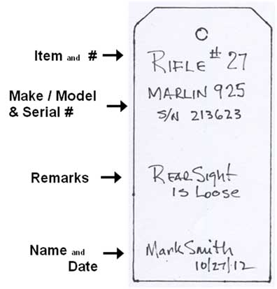

**APPENDIX C-1**

**ARCHERY Range Commands**

… to begin the relay …

* **2 – Whistle Blasts:** ***"TO THE LINE”*** means for archers to move from the waiting line, pick-up their Bow, and take their assigned position straddling the shooting line. Do not nock an arrow.

… after the archers are in position …

* **1 – Whistle Blast: *"BEGIN SHOOTING”*** means archers are given permission to shoot authorized number of arrows in the end. After shooting the last arrow, the archer steps back off the shooting line, places Bow on rack, and moves to waiting line.

… when all archers have finished shooting …

* **3 – Whistle Blasts: *"RETRIEVE YOUR ARROWS”*** means archers are given permission to walk to the target line, score and retrieve arrows.

***IN CASE OF AN EMERGENCY:***

* **5 or more – Whistle Blasts: *“CEASE FIRE!”*** is called by the range officer if any incident occurs that may result in possible injury to some living thing should firing continue. DO NOT SHOOT !! Let down the arrow, un-nock and return arrow to quiver, and await further instruction.

**APPENDIX C-2**

**RIFLE & PISTOL Sample Range Commands**

* **"SHOOTERS TO THE FIRING LINE”** means for shooters to take their assigned place at their firing point, remove the Empty Chamber Indicator, and prepare to fire, but do not load.
* **“THE COURSE OF FIRE WILL BE ## SHOTS, WITH ## SHOTS PER TARGET. YOU WILL HAVE xx MINUTES”**
* **“IS THE LINE READY?”** allows a shooter with problems to raise hand and call “NOT READY”

The range officer will immediately state: “THE LINE IS NOT READY”.

* **"LOAD”** means shooters are given permission to load authorized number of rounds and prepare for the shooting event.
* **“COMMENCE FIRING!”** means to shoot the course of fire.
* **“CEASE FIRE—ACTIONS OPEN—MAKE SAFE—INSTALL THE ECI** !” Notifies shooters firing is ended. All rifle chambers and magazines are unloaded, magazines removed, install the empty chamber indicator, and shooters leave the firing line with the actions of their firearms open.

***IN CASE OF AN EMERGENCY:***

**“CEASE FIRE!”** Notifies shooters to stop firing immediately and await instructions. It will be called by the Range Safety Officer (or anyone on the range) if any incident occurs that may result in possible injury to some living thing should firing continue.

**APPENDIX C-3**

**SHOTGUN Sample Range Commands**

* **"TO YOUR STATION”** means for shooters to take their assigned place at their firing point, remove the empty chamber indicator, but do not load.
* **“THE RANGE IS HOT. INSTRUCTORS (COACHES) TAKE CHARGE OF YOUR STATIONS!”** means that the Instructor now has control of the shooters under his/her responsibility to shoot the course of fire.
* **“TRAPPER READY?”** alerts the trap operator that the shooters are ready to begin.
* **“READY!”** replyby the Trap Operator when first starting the round, to notify the first Shooter that he may call for the target.
* **“PULL!”** Called by the shooter to notify the Trap Operator to release a target. The Trap Operator must not delay in pushing the release button.
* **“CEASE FIRE—ACTIONS OPEN—MAKE SAFE—INSTALL THE ECI** !” Notifies shooters firing has ended, all shotgun chambers and magazines are unloaded, install the empty chamber indicator, and shooters leave the firing line with the actions of their shotguns open.

***IN CASE OF AN EMERGENCY:***

**“CEASE FIRE!”** Notifies all shooters to stop firing immediately and await instructions. It will be called by the Range Safety Officer (or anyone on the range) if any incident occurs that may result in possible injury to some living thing should firing continue.

**APPENDIX D**

**Archery Merit Badge**

* Qualification shooting at 10 yards using a 32” (80 cm.) target use the scoresheet below.

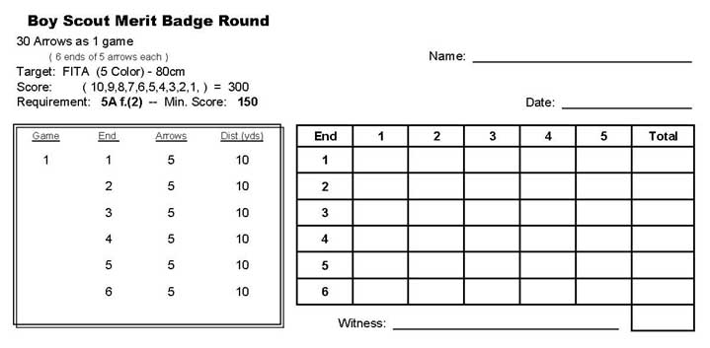

* Make a complete arrow from a bare shaft.
  + A kit is available for purchase containing the following:
    - 1 each - Fiberglass shaft, target point, and nock.
    - 3 each – plastic vanes
  + 4 arrow jigs are available for use at the archery range.
  + “Fletch-Tite” cement (vanes) and “Super-glue” (nock, point) are available for shared use. Please use sparingly.
* Make a bowstring.
  + Materials are available to make a 10-strand bowstring for a 62” or 66” bow.
    - B50 or B55 dacron bowstring
    - #4 nylon serving thread on serving tool
    - 1 ea. – brass nock locator
  + 4 bowstring jigs with “C” clamps
  + Serving tools and nock pliers are available for shared use at the archery range.

A diagram of the bowstring jig assembly is available may be found in the Archery Range Book in the archery building.

Directions for use of the Jo-Jan Mono Fletcher (arrow fletching jig) may be found in the Archery Range Book.

**APPENDIX E**



**APPENDIX F**

**Steel Reactive Targets for Venturing Pistol only**

* To qualify to shoot Steel Reactive Targets a Venturer must first demonstrate ability to shoot a 5-shot, 5” group at 25’, 2-hand standing, with both Revolver and Semi-automatic Pistol.
* Steel targets will be shot at a minimum distance of 10 yards, using only handguns with .22LR ammunition.
* Targets will be set at the 25 yd. line at the berm. Only shooters and instructors will be at the firing line.
* Steel targets must be mounted with a 5°-10° forward lean to avoid ricochet. See target specifications.

Targets available:

(2) Rimfire Sport Dueling Tree (2) Rimfire Auto-Reset (5”) Target

(1) Rimfire Plate Rack (2) Rimfire Paddle (4”) Target

(1) Rimfire Spinning Jack

Spray paint, black or other color, will be available to reface the metal targets. All targets will be repainted when storing after use.

Reactive Target Challenge Events -- 1

WSSC Dueling Tree Challenge (15 rounds):

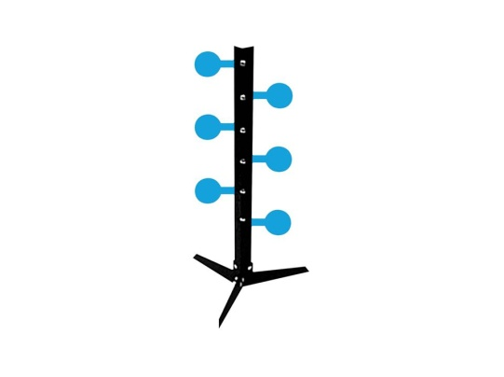2 shooters per tree, at 10 yards minimum. Three alternating paddles set to left and right side. Semi-auto Pistol, each with 2 magazines. Shooters will load 7 rounds in one magazine and 8 rounds in the second magazine. On the command “Load” shooter will install first magazine and cycle first round into the chamber. On the command “Commence Firing” shooters will begin the game, when first magazine is empty, keeping the pistol pointed down range, shooters will drop magazine and install second magazine, continuing to shoot until all 15 rounds are fired. Shooter with fewest paddles on his side is declared the winner.

WSSC Plate Rack Challenge (12 rounds):

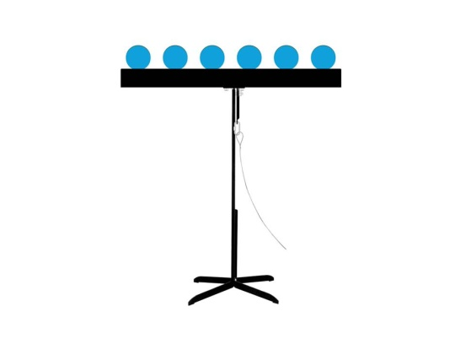1 shooter, at 10 yards minimum. Six plates set. Single Action Revolver. Shooter will load 6 rounds in the cylinder and place revolver on table. Timer will be set at 90 sec. On command “Commence Firing” shooter will pick up revolver and begin the game firing one round at each standing plate. After 6 shots, plates will be reset and shooter will extract spent brass, reload 6 rounds, and continue firing at the second set of 6 plates, all within the time limit.

Reactive Target Challenge Events -- 2

WSSC Spinning Jack Challenge (15 rounds):

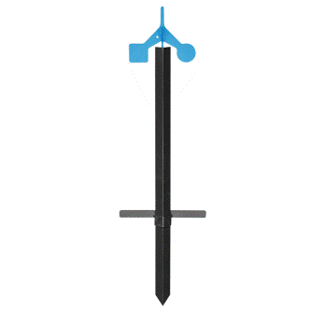1 shooter, at 10 yards minimum. Spinning Jack target. Single Action Revolver and Semi-auto Pistol. Shooter will load 6 rounds in the cylinder and place revolver on table. 9 rounds will be loaded in the Semi-Auto magazine and placed on the table next to the pistol. Timer will be set at 45 sec. On command “Commence Firing” shooter will pick up revolver and begin the game firing one round at the Spinning Jack. After 6 shots, place the revolver on the table, install magazine in Semi-Auto and continue shooting 9 rounds. Remove magazine and place pistol on table.

WSSC Paddle Target Challenge (15 rounds):

1 shooter, at 10 yards minimum, 4 steel targets set 18”-24” apart at the 25yd line. Single Action Revolver and Semi-auto Pistol. Shooter will load 6 rounds in the cylinder and place revolver on table. 9 rounds will be loaded in the Semi-Auto magazine and placed on the table next to the pistol. Timer will be set at 45 sec. On command “Commence Firing” shooter will pick up revolver and begin the game firing one round at the first plate. One shot will be fired at each target in the following sequence, left-to-right: 1,2,3,4,3,2,1,2,3,4,3,2,1,etc. If a plate is missed, shooter will shoot at that target until hit, then continue in the sequence. After 6 shots, place the revolver on the table, install magazine in Semi-Auto and continue shooting 9 rounds. Remove magazine and place pistol on table. Time ends.

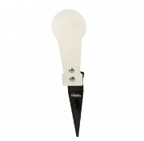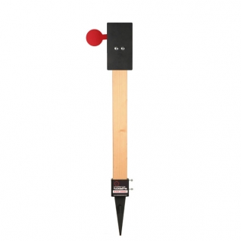

1 2 3 4

**APPENDIX G**

Shotgun Games and Field Layout -- 1

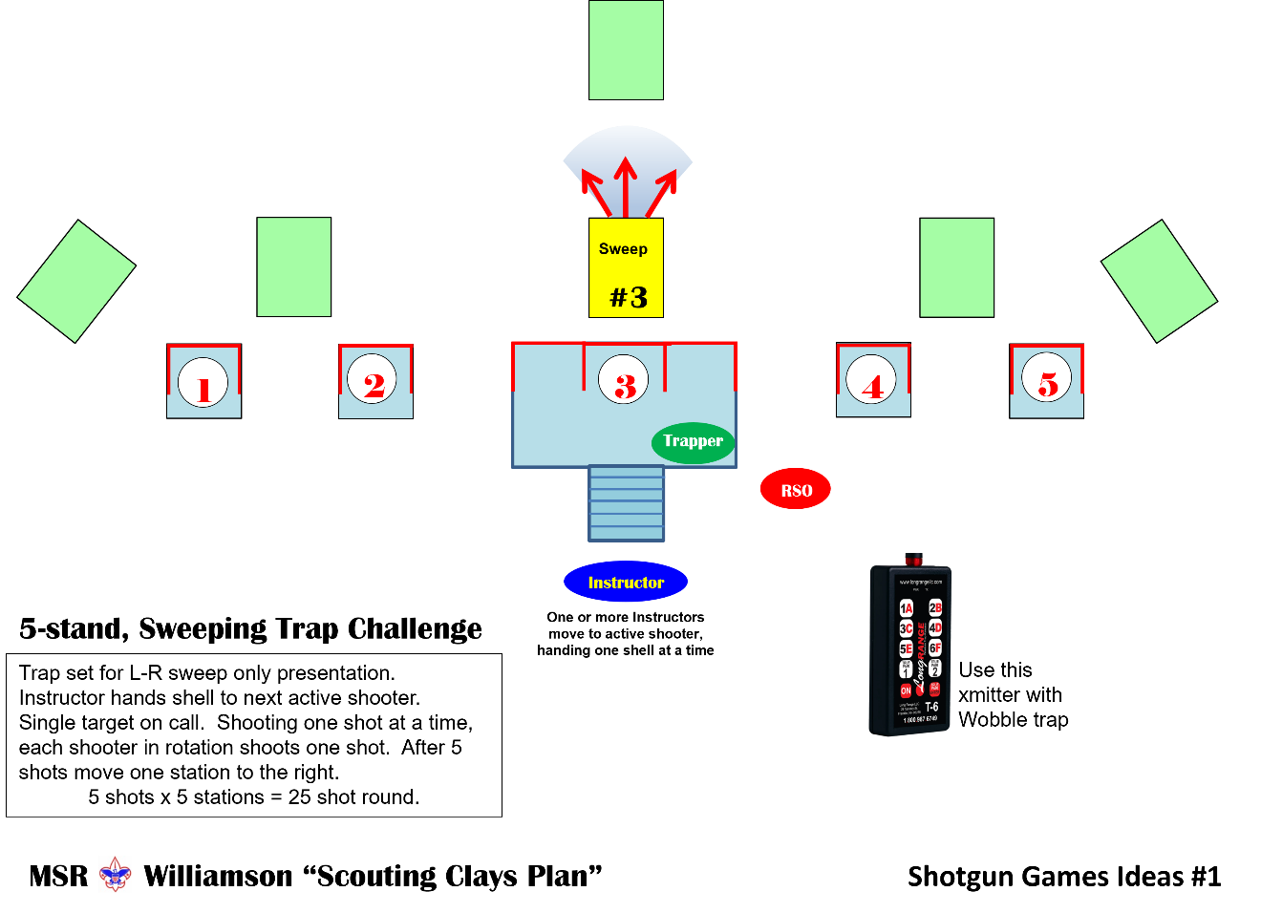

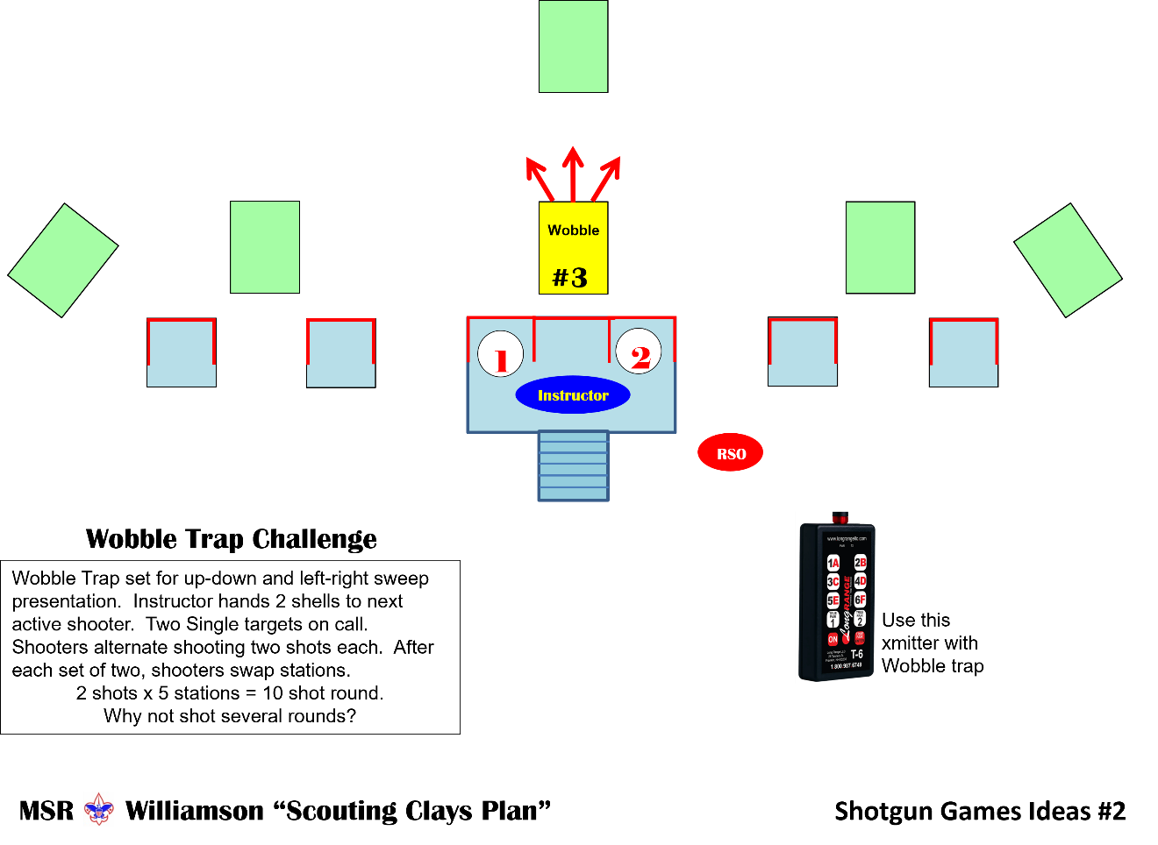

Shotgun Games and Field Layout -- 2

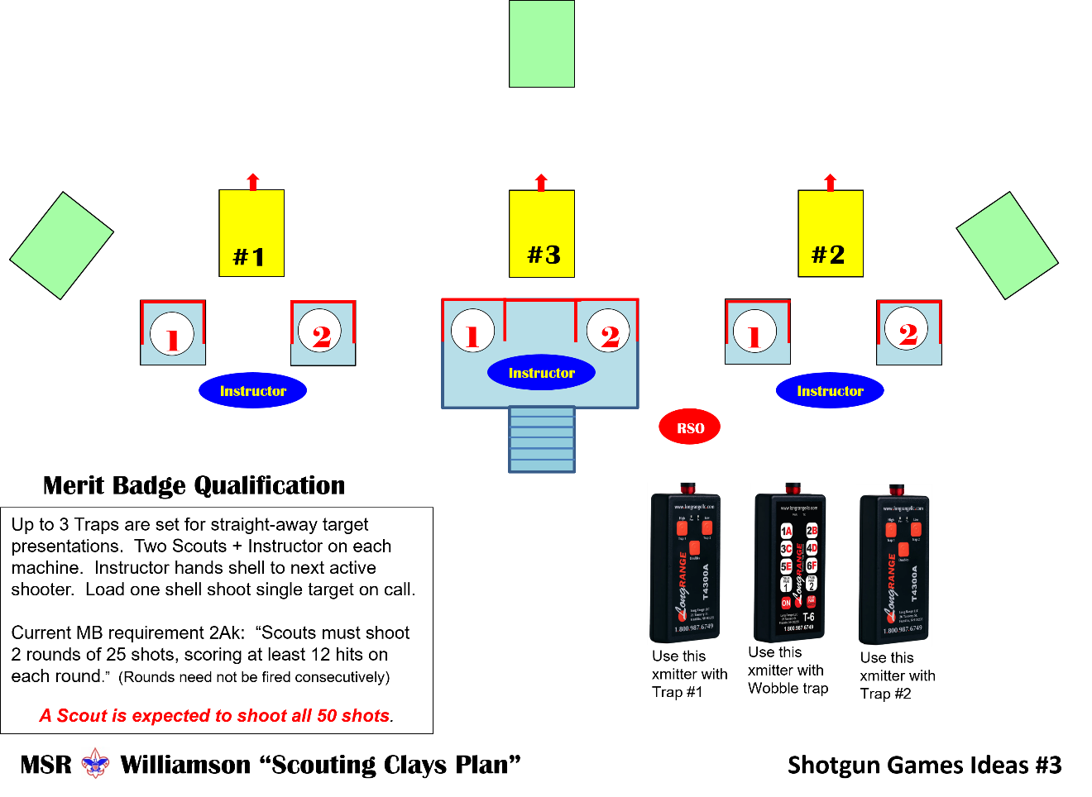

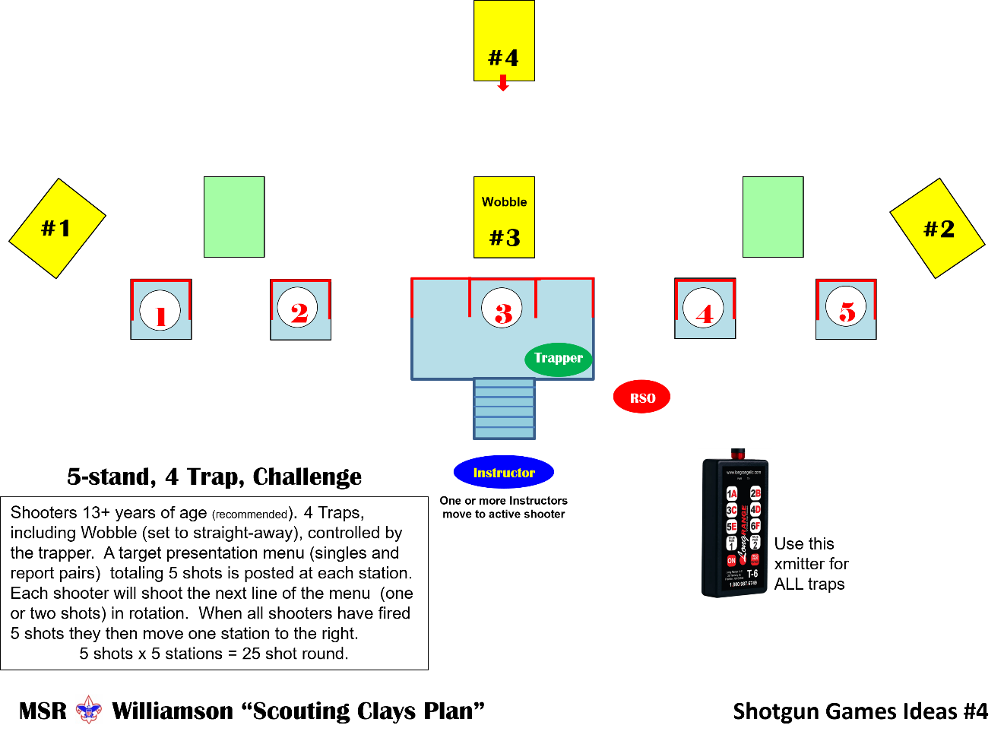

Shotgun Games and Field Layout -- 3



